

**Question 1:**

Listen to the following telephone conversation between an American man and woman.

<https://www.onestopenglish.com/download?ac=293> **Answer the following questions:**

-What’s the relationship between Kevin and Anne?

* Who is Dennis?
* Who are Becky and Kate?

**Text from audio**

Listen to Kevin telephone his sister in Australia. Hello. Hi, Anne. Kevin. What a surprise. It's great to hear from you. How are you? Fine, just fine. How about you? What's new? Oh, nothing much. How's Dennis? He's very well. He's won a golf competition, so he's thrilled about that. A golf competition? That's great. When was that? Last Saturday. Well, tell him congratulations. And how about the kids? How are Becky and Kate? Becky's had an argument with her boyfriend, so she's a bit upset at the moment. Oh, dear. Is it serious? Well, I don't know. It only happened this morning. This morning? Poor Becky. But Kate has some good news. She's passed her driving test. Great. That is good news. Yes, she's thrilled.

She passed the test on Friday. Wonderful. And what about you, Kevin? How are you? I'm fine. I have some news, too, actually. You're going to be very surprised. Go on. I've gotten engaged. No. What? When? Last week. It all happened very quickly. Oh, Kevin, I don't know what to say.

* Kevin and Anne are siblings. Kevin refers to Anne as his sister.
* Dennis is likely a family member or a close friend mentioned in the conversation. He is well and has recently won a golf competition.
* Becky and Kate are likely Kevin's nieces, as they are mentioned in relation to him. Becky had an argument with her boyfriend, and Kate passed her driving test.

**question 2**

**Listen To this audio and do the following tasks.**

[https://youtu.be/0rAfld6CPxc?si=asnoTDrm0tr_IzHs ](https://youtu.be/0rAfld6CPxc?si=asnoTDrm0tr_IzHs)

**Text from video**

Once again, the organization which promotes Australia tourism. Australia is advertising the best job in the world, but this year they have six jobs going all for six months with a great salary and extra spending money. If you think one of these is your dream job, you have to make a 32nd video explaining why you are the best person for the role. But be warned, thousands of people will be competing for each post. The job of outback adventurer is for someone with a passion for outdoor life and in the northern Territory there are plenty of wide open spaces. The job is for someone to find out the best adventures and jobs for young people. On working holidays. You'd be getting close to wildlife, sleeping under the stars in a bush camp and flying over stunningly beautiful landscape in a hot air balloon. Your duties will include getting to know about aboriginal culture and eating traditional bush foods, maybe including the famous witchety grubs, insect lava, like the idea of 200 days of sunshine every year. Job number two is a park ranger in tropical Queensland. It's a wonderful state with ancient rainforests, the world's largest sand island and the awesome Great Barrier Reef. Here your duties would include protecting and promoting native plants and animals, spectacular waterfalls, dinosaur fossils, untouched beaches and indigenous culture. You'd get paid to patrol the beaches of Lizard island and live a life most people can only dream about. Another island job is as wildlife caretaker on Kangaroo island in South Australia. If you love all kinds of animals, this is the job for you. The advert says. You'll be able to talk to wallabies, a kind of small kangaroo, play with dolphins, cuddle koalas and sunbathe with seals on the unspoilt beach at Seal Bay. You would get about the island on foot, by bicycle, kayak or boat, taking photos and leaving only footprints. There is one potential drawback though. You'd need to be pretty brave since you might come face to face with great white sharks. Maybe you are not quite so keen on the great outdoors and your talents are more journalistic. If you fancy feature writing, photography and making videos, you can apply for the position of lifestyle photojournalist for Time out in Melbourne, you would be required to photograph and write about the city's coolest cafes and musical events, but you'd also cover tourist activities in the whole state of Victoria, including surfing on the great Ocean Road, skiing at Mount Hotham or watching the little penguins at Philip island. Are you a foodie? Do you know about food as well as love eating it? If the answer is yes, you can apply for the role of Tastemaster in Western Australia. Your job will be to promote the best restaurants, pubs, wineries and breweries. You'd also catch fresh seafood off the beautiful coast and learn all about making wine and beer. Finally, a fantastic job in Sydney. We've all seen those amazing firework displays in Sydney Harbour. Well, you could be one of the people making that happen. Next year, New South Wales is looking for a chief funster who would be based in Sydney while traveling around the state and tweeting about the coolest things going on. This job would appeal to someone interested in everything, sports, the arts, entertainment, food. You'd also be involved in making the Sydney festival, Mardi Gras and vivid festival as spectacular and as fun as possible. This recording was brought to you by the British Council. To find others like it, visit www.britishcouncil.org forward slash learnEnglishteans.

**question 1: Check your understanding: Gap fill**

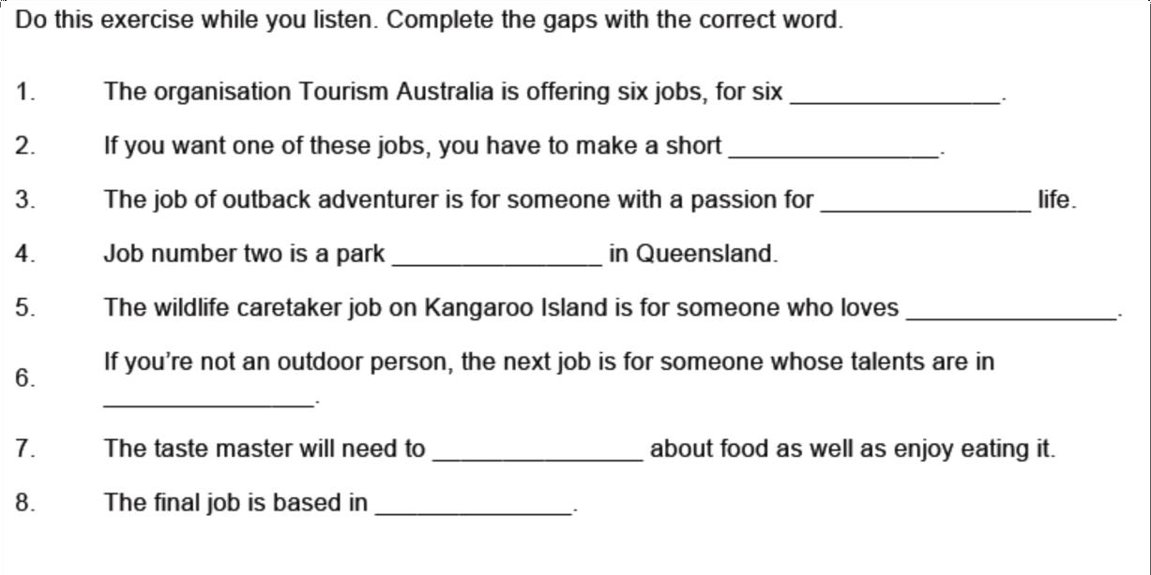

Do this exercise while you listen. Complete the gaps with the correct word.

1. The organisation Tourism Australia is offering six jobs, for six….
2. If you want one of these jobs, you have to make a short…..
3. The job of outback adventurer is for……. someone with a passion for life.
4. Job number two is a park……in Queensland.
5. The wildlife caretaker job on Kangaroo Island is for someone who loves…..
6. If you're not an outdoor person, the next job is for someone whose talents are in…..
7. The taste master will need to….. about food as well as enjoy eating it.
8. The final job is based in…..

**Answers :**

1. The organization Tourism Australia is offering six jobs, for six months.
2. If you want one of these jobs, you have to make a short 32-second video.
3. The job of outback adventurer is for someone with a passion for outdoor life.
4. Job number two is a park ranger in Queensland.
5. The wildlife caretaker job on Kangaroo Island is for someone who loves all kinds of animals.
6. If you're not an outdoor person, the next job is for someone whose talents are in journalistic activities.
7. The Tastemaster will need to know about food as well as enjoy eating it.
8. The final job is based in Sydney.