Summative Assessment

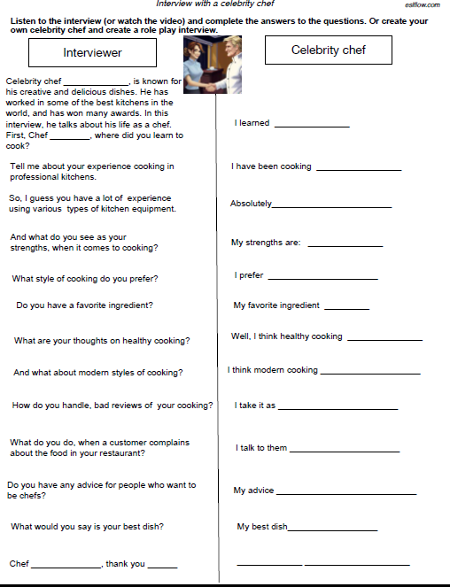1/ This is a role play and listening/speaking exercise with a celebrity chef. Watch the following video and do the activity below: <https://youtu.be/GdAaa6h7_sE?si=5Hl0VZ4opequcPB7>

Text from video

**Celebrity chef** **Jordan Hamsey is known for his creative and delicious dishes. He has worked in some of the best kitchens in the world and has won many awards. In this interview, he talks about his life as a chef. First, chef Hamsey, where did you learn to cook? I learned to cook from my mum and dad. They are both great cooks and I always loved watching them in the kitchen. Tell me about your experience cooking in professional kitchens. I have been cooking in professional kitchens for over 20 years. I have worked in some of the best restaurants in the world and consequently I have gained a lot of experience with different types of cooking. So I guess you have a lot of experience using various types of kitchen equipment. Absolutely. I have experience using everything you can imagine, including many kinds of ovens, stoves, microwaves and of course, dishwashers. And what do you see as your strengths when it comes to cooking? My strengths are being able to follow recipes accurately and always working quickly and efficiently. I know that you can cook just about anything, but what style of cooking do you prefer? I prefer to cook food that is simple and classic. Do you have a favorite ingredient? Oh, yes. My favorite ingredient to work with is garlic. It has so much flavor and can be used in so many different dishes. What are your thoughts on healthy cooking? Well, I think healthy cooking is important, but I also think it's important to balance healthy cooking with tasty dishes. My cooking is about creating dishes that make people feel good. And what about modern styles of cooking? I think modern cooking is a great way to experiment with new flavors and combinations. How do you handle bad reviews of your cooking? I take it as useful feedback that drives me to improve my recipes and my dishes. What do you do when a customer complains about the food in your restaurant? I talk to them and listen to them and try to understand exactly what they don't like and what they really want. Do you have any advice for people who want to be chefs? My advice for anyone who wants to be a chef is to never give up. It's a difficult industry, but it's so rewarding. What would you say is your best dish? My best dish is my mother's recipe for chicken pot pie. Chef Jordan Hamsey. Thank you for your time. It's been a pleasure to talk with you. The pleasure is all mine. I love talking with fans of food and cooking.**

|  |  |
| --- | --- |
|  |  |
| Interviewer | **Celebrity chef** |
| Celebrity chef Jordan Hamsey is known for  his creative and delicious dishes. He has  worked in some of the best kitchens in the  world, and has won many awards. In this  interview, he talks about his life as a chef.  First, Chef Jordan Hamsey where did you learn to  cook?  Tell me about your experience cooking in  professional kitchens.  So, I guess you have a lot of experience  using various types of kitchen equipment.  And what do you see as your  strengths, when it comes to cooking?  What style of cooking do you prefer?  Do you have a favorite ingredient?  What are your thoughts on healthy cooking?  And what about modern styles of cooking?  How do you handle, bad reviews of your cooking?  What do you do, when a customer complains  about the food in your restaurant?  Do you have any advice for people who want to  be chefs?  What would you say is your best dish?  Chef  thank you | * I learned to cook from my mum and dad. * I have been cooking in professional kitchens for over 20 years. * Absolutely, I have experience using everything you can imagine, including many kinds of ovens, stoves, microwaves, and of course, dishwashers. * My strengths are: being able to follow recipes accurately and always working quickly and efficiently. * I prefer to cook food that is simple and classic. * My favorite ingredient is garlic. * Well, I think healthy cooking is important, but I also think it's important to balance healthy cooking with tasty dishes. * I think modern cooking is a great way to experiment with new flavors and combinations. * I take it as useful feedback that drives me to improve my recipes and my dishes. * If a customer complains about the food in my restaurant, I talk to them and listen to them and try to understand exactly what they don't like and what they really want. * My advice for anyone who wants to be a chef is to never give up. * My best dish is my mother's recipe for chicken pot pie. |
|  |  |
|  |  |
|  |  |
|  |  |
|  |  |

<https://eslflow.com/wp-content/uploads/2022/10/Interview-with-a-celebrity-chef.pdf>

2/ This is a role play speaking activity. Watch the video and answer the questions below by expressing opinions about the topic of online shopping.

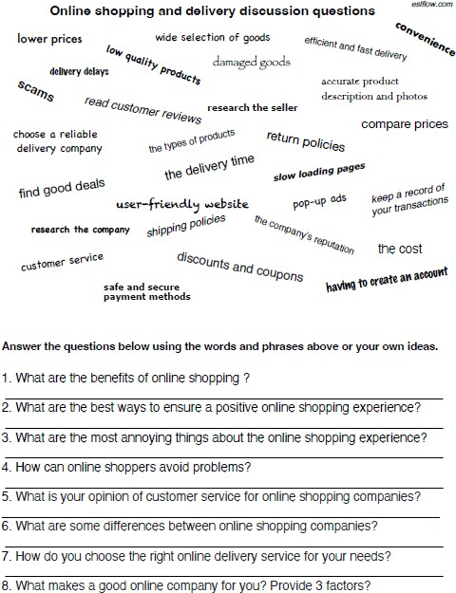

Online shopping and delivery discussion questions

lower prices

wide selection of goods

delivery delays

scams

low quality products

read customer reviews

choose a reliable

delivery company

find good deals

damaged goods

research the seller

the types of products

the delivery time

user-friendly website

research the company shipping policies

customer service

safe and secure

payment methods

efficient and fast delivery

return policies

discounts and coupons

slow loading pages

pop-up ads

the company's reputation

esiflow.com

convenience

accurate product

description and photos

compare prices

keep a record of

your transactions

the cost

having to create an account

Answer the questions below using the words and phrases above or your own ideas.

**Questions**

1. What are the benefits of online shopping ?

2. What are the best ways to ensure a positive online shopping experience?

3. What are the most annoying things about the online shopping experience?

4. How can online shoppers avoid problems?

5. What is your opinion of customer service for online shopping companies?

6. What are some differences between online shopping companies?

7. How do you choose the right online delivery service for your needs?

8. What makes a good online company for you? Provide 3 factors?

**Answers**

1. **Pros of Online Shopping:**
   * Enjoy cost savings with lower prices.
   * Access a vast array of goods and products.
   * Benefit from the convenience of shopping from anywhere.
   * Access accurate product descriptions and visuals.
   * Research sellers and compare prices easily.
   * Keep a transaction history for reference.
   * Avail discounts and coupons.
2. **Tips for a Positive Online Shopping Experience:**
   * Read customer reviews for informed decisions.
   * Choose a reliable shipping company.
   * Understand and research shipping and return policies.
   * Use secure payment methods.
   * Opt for efficient and fast shipping options.
   * Maintain a record of transactions for tracking.
3. **Drawbacks of Online Shopping:**
   * Encounter slow-loading pages.
   * Deal with annoying pop-up ads.
   * Beware of scams and phishing attempts.
   * Face issues with low-quality products.
   * Experience delays and damages in shipping.
   * Encounter the necessity to create accounts.
4. **Avoiding Problems in Online Shopping:**
   * Conduct thorough research before purchasing.
   * Verify product variety and company reputation.
   * Watch for red flags like unusually low prices.
   * Stay alert to potential scams and phishing.
   * Be cautious of negative customer reviews.
5. **Diverse Customer Service Experiences:**
   * Customer service quality varies widely.
   * Ideal online shopping companies offer accessible support.
   * Prioritize transparent communication on orders and returns.
   * Resolve issues promptly for customer satisfaction.
6. **Key Differences Among Online Shopping Companies:**
   * Consider price points when choosing.
   * Evaluate product services and variety.
   * Assess shipping speeds and return policies.
   * Weigh the overall user experience.
7. **Selecting an Online Delivery Service:**
   * Evaluate reliability, speed, and pricing.
   * Check customer reviews and demographics.
   * Compare services to find the right fit.
8. **Qualities of a Good Online Company:**
   * Emphasize security for customer trust.
   * Provide high-quality products.
   * Maintain excellent customer service standards.

**Answers**

1. Embracing online shopping brings advantages such as enjoying lower prices, accessing a vast selection of goods, experiencing the convenience of shopping from anywhere, benefiting from accurate product descriptions and visuals, easily researching and comparing prices, keeping a handy transaction history, and gaining access to discounts and coupons.
2. For a positive online shopping experience, it's wise to read customer reviews, opt for a reliable shipping company, thoroughly understand and research shipping and return policies, use secure payment methods, choose efficient and fast shipping options, and maintain a comprehensive record of transactions.
3. However, online shopping comes with its drawbacks, including encountering slow-loading pages, dealing with annoying pop-up ads, being wary of scams and phishing attempts, facing issues with low-quality products, experiencing delays and damages in shipping, and the inconvenience of having to create accounts.
4. To avoid problems in online shopping, consumers should conduct thorough research before purchasing, verify the variety of products and the reputation of the company, be alert to red flags like unusually low prices, and exercise caution regarding potential scams and phishing, all while being mindful of negative customer reviews.
5. The customer service experience in online shopping companies varies widely, with ideal ones offering easily accessible support, prioritizing transparent communication on orders and returns, and resolving any issues promptly for customer satisfaction.
6. Significant differences among online shopping companies include considerations of price points, evaluation of product services and variety, assessment of shipping speeds and return policies, and an overall weighing of the user experience.
7. When selecting an online delivery service, consumers should carefully evaluate factors such as reliability, speed, and pricing, checking customer reviews and demographics, and comparing different services to find the one that best suits their specific needs.
8. A good online company, in my opinion, should prioritize security to build customer trust, deliver high-quality products, and maintain excellent customer service standards, ultimately ensuring that customers feel confident in their decision to make purchases from that particular brand.

**Haut du formulaire**