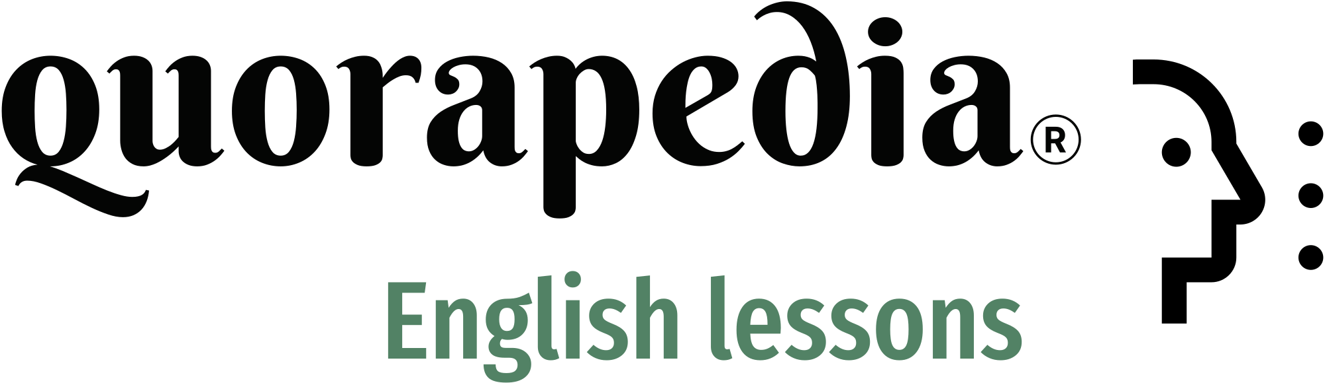

**Title: Verb Tense Selection: Practice Activity with Explanations**

1. **By this time next year, I (will graduate / will have graduated) from university.**
2. **She (walks / walked) to school every day last year.**
3. **I (am cooking / cook) dinner right now, so I can’t come to the phone.**
4. **When we arrived, the concert (had already started / already started).**
5. **She (has lived / lived) in Paris for five years now.**
6. **They (are going / go) to the park every weekend.**
7. **By the time you get home, I (will finish / will have finished) cleaning the house.**
8. **He (is reading / reads) a book every night before bed.**
9. **They (were waiting / waited) for the bus when it started raining.**
10. **I (will have / will be having) a meeting at 3 PM tomorrow.**

**Answers**

1. **will have graduated**  
   **Explanation**: The future perfect tense "will have graduated" is used because it refers to an action that will be completed by a specific time in the future.
2. **walked**  
   **Explanation**: The past simple tense "walked" is appropriate here because the action took place regularly in the past, indicated by "last year."
3. **am cooking**  
   **Explanation**: The present continuous tense "am cooking" is used because it describes an action happening at the moment of speaking.
4. **had already started**  
   **Explanation**: The past perfect tense "had already started" is correct because it indicates that the concert began before we arrived.
5. **has lived**  
   **Explanation**: The present perfect tense "has lived" is used because it refers to an action that started in the past and continues into the present.
6. **go**  
   **Explanation**: The present simple tense "go" is used for habitual actions or routines.
7. **will have finished**  
   **Explanation**: The future perfect tense "will have finished" indicates that the action will be completed by the time another future event occurs.
8. **reads**  
   **Explanation**: The present simple tense "reads" is used to describe a regular habit.
9. **were waiting**  
   **Explanation**: The past continuous tense "were waiting" is used to describe an action that was in progress at a specific time in the past.
10. **will be having**  
    **Explanation**: The future continuous tense "will be having" is used to indicate that an action will be ongoing at a specific time in the future.

**Activity: Verb Tense Selection**

**Instructions**: Read each sentence below and choose the correct verb tense from the options provided. Then, explain why the selected verb tense is appropriate based on the context of the sentence.

1. **I (am studying / study) for my exams right now.**
2. **They (have visited / visited) the museum last weekend.**
3. **By the time we arrive, they (will leave / will have left).**
4. **He (reads / is reading) a novel every month.**
5. **We (were watching / watched) TV when the power went out.**
6. **She (has never been / was never) to Japan before.**
7. **They (are playing / play) soccer every Saturday.**
8. **By next year, I (will be living / will have lived) in New York for a decade.**
9. **The train (leaves / is leaving) at 9 AM tomorrow.**
10. **He (didn’t finish / hasn’t finished) his homework yet.**
11. **We (will go / will have gone) to the party after we finish work.**
12. **She (was cooking / cooked) dinner when the guests arrived.**
13. **I (have worked / worked) here since 2015.**
14. **They (are visiting / will visit) their grandparents next weekend.**
15. **She (used to play / was playing) the piano when she was younger.**
16. **The store (is opening / opens) at 10 AM every day.**
17. **By the time you read this, I (will have left / will be leaving) the country.**
18. **She (has been running / is running) for an hour and she’s still going.**
19. **I (have never seen / never saw) such a beautiful sunset before.**
20. **We (were having / have had) dinner when the phone rang.**
21. **They (are moving / move) to a new house next month.**
22. **She (will have completed / will complete) the project by the deadline.**
23. **I (have visited / visited) Italy three times already.**
24. **When I was a child, I (used to / was) afraid of the dark.**
25. **They (will be attending / attend) a wedding this weekend.**
26. **By the end of this month, we (will have saved / save) enough money.**
27. **She (has been working / works) at the company for two years.**
28. **The movie (starts / is starting) in five minutes.**
29. **He (will study / is studying) law after he finishes his degree.**
30. **I (am going / go) to the gym three times a week.**

**Answers**

1. **am studying**  
   **Explanation**: Present continuous tense "am studying" is used because it describes an action happening at the moment of speaking.
2. **visited**  
   **Explanation**: Past simple tense "visited" is appropriate because the action took place at a specific time in the past, indicated by "last weekend."
3. **will have left**  
   **Explanation**: Future perfect tense "will have left" is used because it refers to an action that will be completed before another future event.
4. **reads**  
   **Explanation**: Present simple tense "reads" is used to describe a habitual action.
5. **were watching**  
   **Explanation**: Past continuous tense "were watching" is used to describe an action that was in progress at a specific time in the past.
6. **has never been**  
   **Explanation**: Present perfect tense "has never been" is used because it refers to an experience up until now.
7. **play**  
   **Explanation**: Present simple tense "play" is used for habitual actions or routines.
8. **will have lived**  
   **Explanation**: Future perfect tense "will have lived" indicates that the action will be completed by a certain time in the future.
9. **leaves**  
   **Explanation**: Present simple tense "leaves" is used for scheduled events in the future.
10. **hasn’t finished**  
    **Explanation**: Present perfect tense "hasn’t finished" is used because it refers to an action that is expected to be completed, but hasn’t been yet.
11. **will go**  
    **Explanation**: Future simple tense "will go" is used to indicate a decision or action that will take place in the future.
12. **was cooking**  
    **Explanation**: Past continuous tense "was cooking" is used to describe an action that was in progress when another action occurred.
13. **have worked**  
    **Explanation**: Present perfect tense "have worked" is used because it refers to an action that started in the past and continues into the present.
14. **are visiting**  
    **Explanation**: Present continuous tense "are visiting" is used for planned future actions.
15. **used to play**  
    **Explanation**: "Used to" indicates a habitual action that occurred in the past but no longer happens.
16. **opens**  
    **Explanation**: Present simple tense "opens" is used for regular schedules or routines.
17. **will have left**  
    **Explanation**: Future perfect tense "will have left" indicates that the action will be completed by a specific time in the future.
18. **has been running**  
    **Explanation**: Present perfect continuous tense "has been running" is used to describe an action that started in the past and is still ongoing.
19. **have never seen**  
    **Explanation**: Present perfect tense "have never seen" is used to describe an experience up until now.
20. **were having**  
    **Explanation**: Past continuous tense "were having" describes an action that was in progress when another event occurred.
21. **are moving**  
    **Explanation**: Present continuous tense "are moving" is used for planned future actions.
22. **will have completed**  
    **Explanation**: Future perfect tense "will have completed" indicates that the action will be finished by a specific future time.
23. **have visited**  
    **Explanation**: Present perfect tense "have visited" is used to describe experiences up to the present.
24. **used to**  
    **Explanation**: "Used to" is appropriate for a past habit that no longer happens.
25. **will be attending**  
    **Explanation**: Future continuous tense "will be attending" indicates an action that will be ongoing at a specific future time.
26. **will have saved**  
    **Explanation**: Future perfect tense "will have saved" indicates that the action will be completed by a certain time in the future.
27. **has been working**  
    **Explanation**: Present perfect continuous tense "has been working" is used to describe an action that started in the past and continues into the present.
28. **starts**  
    **Explanation**: Present simple tense "starts" is used for scheduled events in the near future.
29. **is studying**  
    **Explanation**: Present continuous tense "is studying" is used to describe a planned action in the future.
30. **go**  
    **Explanation**: Present simple tense "go" is used to describe a habitual action.